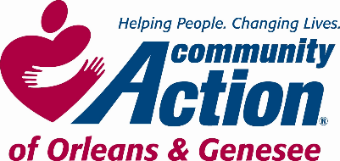 **POSITION ANNOUNCEMENT**

**To Provide Services, with Dignity and Respect, That Help People Become Self-Sufficient**

[***www.caoginc.org***](http://www.caoginc.org)

**QUESTIONS OR RESUME TO:**

***Human Resources & Payroll Administrator***

***409 East State Street***

***Albion, NY 14411***

[***hr@caoginc.org***](mailto:hr@caoginc.org) ***(585)589-5605***

**RESPOND BY: Posting will remain open until positions are filled.**

*Note: Internal Candidates may respond with a letter of interest and resume*.

**POSITION: Head Start Teacher Assistant /**

**Bus Monitor / Floaters & Substitutes**

*Multiple positions available.*

**LOCATIONS: Batavia Head Start**

**Medina Head Start**

**HOURS/PAY: schedules vary, 36 weeks/year\***

**Part-time and Full-Time**

**Between 7:00 AM & 5:30 PM**

**Monday – Friday**

**Minimum Wage**

*\* school holidays, winter, spring & summer breaks off*

**MAJOR RESPONSIBILITIES**

* Cooperate in a supportive role and assist the teaching team in carrying out developmentally appropriate activities for a classroom setting. S/he will promote the health, nutrition, and education of the children and attend to their safety and welfare.
* Assist the Bus Driver with loading and unloading children from the bus, including securing seat belts. S/he will promote bus safety by helping the children to stay in their seats and monitoring their behavior to help the children follow the bus rules.
* As needed, assist the Cook or Cook Assistant in the kitchen, and perform duties requested by Site Coordinator including janitorial or clerical duties and telephone answering

**REQUIRED MINIMUM QUALIFICATIONS**

* At least 18 years of age.
* High School Diploma/GED
* Proven ability to work with young children.
* Clearance through NYS Central Registry for Child Abuse and Maltreatment, NYS

Justice System SEL, and Dept. of Justice fingerprinting required.

* Ability to pass NYS physical for day care licensing requirements; COVID vaccinated

**DESIRED QUALIFICATIONS**

* CDA and work experience with young children

Community Action is an Equal Opportunity Employer EEO Contact Person: Susan Jessmer

sjessmer@caoginc.org