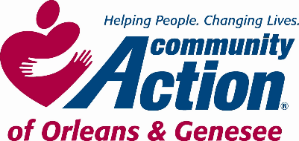 **POSITION ANNOUNCEMENT**

**To Provide Services, with Dignity and Respect, That Help People Become Self-Sufficient**

[***www.caoginc.org***](http://www.caoginc.org)

**QUESTIONS OR RESUME TO:**

***Human Resources & Payroll Administrator***

***409 East State Street***

***Albion, NY 14411***

[***hr@caoginc.org***](mailto:hr@caoginc.org) ***(585)589-5605***

**RESPOND BY: Posting will remain open until position is filled.**

*Note: Internal Candidates may respond with a letter of interest and resume*.

**POSITION: Head Start Preschool Teacher**

**(Teacher Assistant Equivalent)**

**LOCATION: Albion Head Start**

**(E. State St. Site)**

**HOURS: 40 hours/week, 42 weeks/year\***

**7:45 AM–3:45 PM, Mon – Fri**

*\* school holidays, winter, spring*

*& summer breaks off*

**MAJOR RESPONSIBILITIES**

* Works cooperatively with and at the direction of classroom Lead Teacher to promote each child’s total development (cognitive, social/emotional, physical) and school readiness
* Interacts with and engages parents, supports their role as their children’s primary teachers
* Maintains accurate records and prepares reports at direction of Lead Teacher
* Steps in for Lead Teacher as directed

**REQUIRED MINIMUM QUALIFICATIONS**

* 2 years’ experience related to caring for children
* Ability to read and write commensurate with required duties
* Ability to pass NYS physical for day care licensing requirements; COVID vaccinated
* Clearance through NYS Central Registry for Child Abuse, NYS Justice System, and Department of Justice fingerprinting
* Agency Approved Driver status and vehicle required

**EDUCATION**

* CDA or Associate’s Degree in Early Childhood Education
* Candidates with 9 college credits in Early Childhood, Child Development or a related field AND

Enrolled in 1) a CDA credential program that will be complete within 1 year or 2) a program leading to an associate or baccalaureate degree may be considered.

**DESIRABLE QUALIFICATIONS**

* Experience working with preschool children in a classroom setting

Community Action is an Equal Opportunity Employer EEO Contact Person: Susan Jessmer

sjessmer@caoginc.org