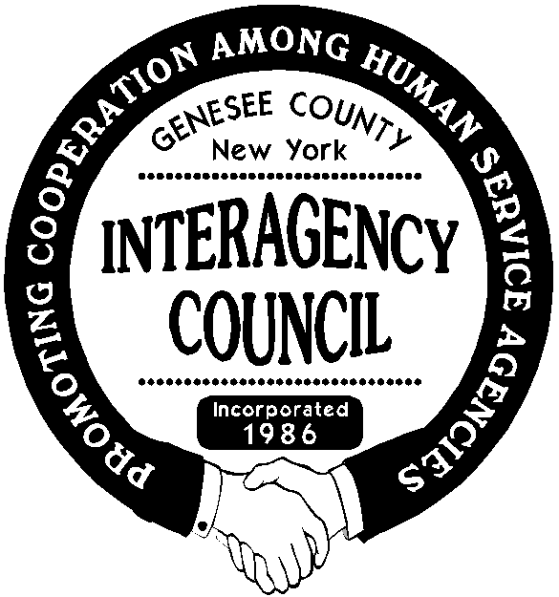***Genesee County Interagency Council, Inc.***

# **P.O. Box 1619**

**Batavia, New York 14021**

To Whom It May Concern,

The Genesee County Interagency Council is pleased to announce that we will be offering a $1000.00 scholarship for the Fall 2023 semester. Those eligible will be **students** **living in Genesee County and attending Genesee Community College;** **in good academic standing, and majoring in Human Services, Social Work, Sociology or Psychology**.

Because the goal of this scholarship is to support those students who have a strong drive to contribute to the field of Human Services, special consideration will be given to those students who have already demonstrated a commitment to the field through their employment, volunteer, academic, and/or extracurricular pursuits.

Completed applications must be received by **Friday May 5, 2023**. The awardee will be notified by June 1, 2023. The award will either be presented at our June 21st picnic meeting at Dewitt Recreation Area or the check will be mailed directly to the individual if the in-person meeting does not occur.

We look forward to having the opportunity to support a Genesee Community College student in their pursuit of a degree in the field of Human Services. Please feel free to contact me at   
(716) 550-0934 should you have any questions.

Sincerely,

Kari Heidemann

Kari A. Heidemann  
Scholarship Committee Member

*The committee reserves the right to withhold the scholarship if there are not enough applicants who meet the minimum qualifications.*