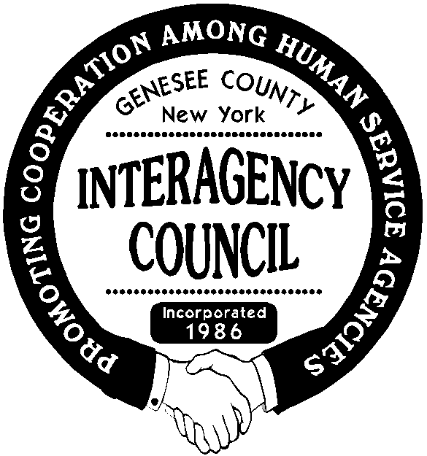***Genesee County Interagency Council, Inc.***

# **P.O. Box 1619**

**Batavia, New York 14021**

To Whom It May Concern,

The Genesee County Interagency Council is pleased to announce that we will be offering a $1000.00 scholarship for the Fall 2023 semester. Those eligible will be **High School Seniors living in and attending high school in Genesee County; in good academic standing, and majoring in Human Services, Social Work, Sociology or Psychology ONLY.**

Because the goal of this scholarship is to support those students who have a strong drive to contribute to the field of Human Services, special consideration will be given to those students who have already demonstrated a commitment to the field through their employment, volunteer, academic, and/or extracurricular pursuits.

The deadline for applications is **Friday, May 5, 2023**. The awardee will be notified by   
June 1, 2023. The award will either be presented at our June 21st picnic meeting or the check will be mailed directly to the individual if the in-person meeting does not occur.

We look forward to having the opportunity to support a Genesee County High School student in their pursuit of a degree in the field of Human Services. Please feel free to contact me at   
(716)550-0934 should you have any questions.

Sincerely,   
Kari Heidemann  
Kari A. Heidemann

Scholarship Committee Member  
  
  
*The committee reserves the right to withhold the scholarship if there are not enough applicants who meet the minimum qualifications.*