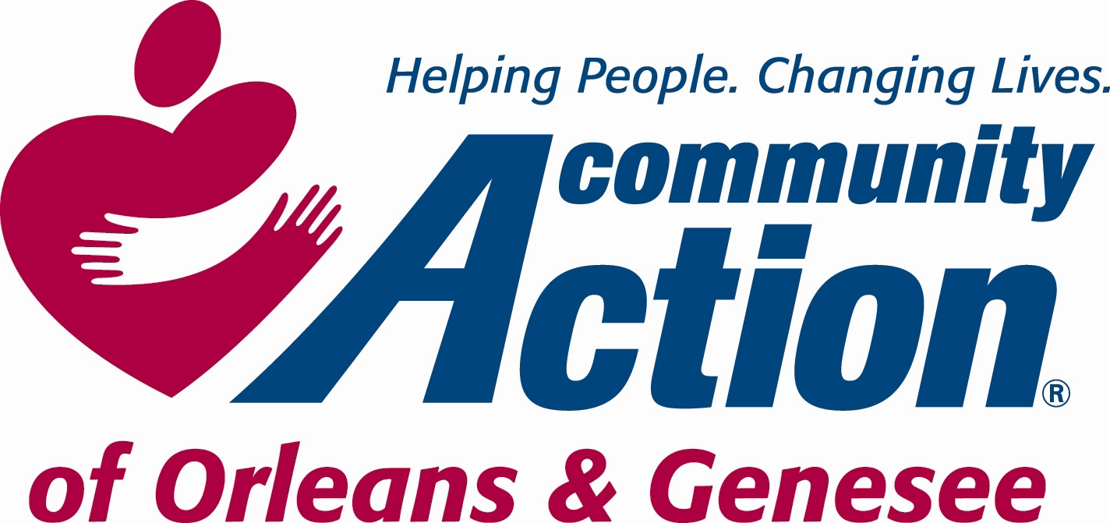 POSITION ANNOUNCEMENT
To Provide Services, with Dignity and Respect, That Help People Become Self-Sufficient
www.caoginc.org

POSITION/TITLE: Part Time Store Associate

POSITION LOCATION Main Street Corner Thrifts, Gifts, and More

PAY/HOURS: $14.20/hour, 20 hours per week

QUESTIONS OR RESUME TO:

Susan Jessmer, HR Administrator
409 East State Street
Albion, NY 14411
hr@caoginc.org 589-5605

RESPOND BY Friday, November 10, 2023

Note: Internal Candidates may respond with a letter of interest and resume.

MAJOR RESPONSIBILITIES

- Maintenance of retail floor merchandise
- Keep updated on retail sales and floor operations
- Maintain retail floor displays for cleanliness and condition
- Provide excellent customer service
- Prioritize safety for staff and customers
- Operate cash register
- Responsible for register, credit card reconciliations as instructed
- Responsible for store open and close process
- Responsible for ensuring and demonstrating professional behaviors/conversation/appearance/ethics
- Follow policies and protocols of store and Community Action
- Handle incoming donations as instructed
- Uphold Community Action confidentiality policies
- Become knowledgeable of Community Action Services
- Online Sales through social media
- General store cleaning as necessary
- Clean and condition incoming furniture/large items
- Other occasional duties as instructed
- Ability to lift up to 30 pounds

Preferred but not mandatory: Valid driver’s license, an acceptable driving record, and acceptable insurance coverage limits per agency policies with own vehicle.

Self-directed, responsible, good organizational skills, able to multi-task, attention to detail, accuracy, excellent verbal and written communication.

Ability to effectively communicate via the phone.

Demonstrated ability to work well on team with supervision and follow directives.

Demonstrated commitment to professional work ethics and contributing to a positive and stable work environment.

Excellent conflict resolution skills and maintain emotional steadiness and control under stress.

Retail Experience is a plus.

REQUIRED MINIMUM QUALIFICATIONS

Community Action is an Equal Opportunity Employer EEO Contact Person: Susan Jessmer
sjessmer@caoginc.org

