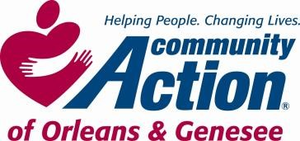

**POSITION ANNOUNCEMENT**

**To Provide Services, with Dignity and Respect, That Help People Become Self-Sufficient**

[***www.caoginc.org***](http://www.caoginc.org/)

|  |  |  |
| --- | --- | --- |
| **POSITION/TITLE: Kitchen Assistant**    **POSITION LOCATION: Batavia Head Start**  **5073 Clinton St. Rd., Batavia, NY**  **PAY/HOURS: 33 hours/week, 42 weeks/year\***  **8:15 AM–3:45 PM, Mon – Wed**  **9:15 AM-3:45 PM, Th – Fri**  **$15/Hour**  *\* school holidays, winter, spring*  *& summer breaks off* |  | **QUESTIONS OR RESUME TO:**  *Human Resources*  *409 East State Street*  *Albion, NY 14411*  *hr@caoginc.org 585-589-5605 x104*    RESPOND BY: 08/20/2024    Note: Internal Candidates may respond with a letter of interest. |

|  |
| --- |
| **MAJOR RESPONSIBILITIES**   * Wash dishes, pots and pans, cleans and sanitizes kitchen * Assists in preparation and delivery of meals for children * Covers for Cook in his/her absence * Follows Federal, State, and local sanitation policies and procedures * Maintains inventory of food, paper, and cleaning supplies and assists with required documentation   **REQUIRED MINIMUM QUALIFICATIONS**   * Valid NYS Driver’s license and vehicle with acceptable record; proof of minimum insurance according to agency policies * NYS physical for daycare licensing required * Clearance through NYS Central Registry for Child Abuse, NYS Justice System for the Protection of People with Special Needs, and Department of Justice fingerprinting. * Ability to lift, up to 50 pounds, bending, and kneeling required   **EDUCATION**   * High School diploma or GED   Community Action is an Equal Opportunity Employer EEO Contact Person: Lisa Elschker-HR Generalist lelschker@caoginc.org |