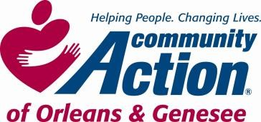

**POSITION ANNOUNCEMENT**

**To Provide Services, with Dignity and Respect, That Help People Become Self-Sufficient**

[***www.caoginc.org***](http://www.caoginc.org/)

|  |  |  |
| --- | --- | --- |
| **POSITION /TITLE: Preschool Teacher**  **POSITION LOCATION: Batavia**  **5073 Clinton St. Rd., Batavia, NY**  **PAY/HOURS: 40 hours/week, 42 weeks/year\***  **7:45 am-3:45pm**  **$16.25-$17.25/hour**  *\* school holidays, winter, spring*  *& summer breaks off* |  | **QUESTIONS OR RESUME TO:**  *Human Resources*  *409 East State Street*  *Albion, NY 14411*  *hr@caoginc.org 585-589-5605 x104*    RESPOND BY: 08/20/2024    Note: Internal Candidates may respond with a letter of interest. |

|  |
| --- |
| **MAJOR RESPONSIBILITIES**   * Practices team teaching with the Lead Teacher * Promotes and maintains a safe environment in order to prevent and reduce injuries. * Provides constant supervision. Promotes good health and nutrition and helps to provide an environment that contributes to the prevention of illness. * Plans and implements activities that promote personal health * Maintains a physical environment which is conducive to active learning. * Implements a consistent daily routine * Involves parents in the classroom program. * Integrates content areas in the classroom.   **REQUIRED MINIMUM QUALIFICATIONS**   * CDA or Associate’s Degree in Early Childhood Education   (Candidates with 9 college credits in Early Childhood, Child Development or a related field and  enrolled in 1) a CDA credential program that will be complete within 2 years or 2) a program leading to an associate or baccalaureate degree may be considered)   * 2 years’ experience related to caring for children * NYS physical examination for day care licensing requirements, including background   Checks.   * Ability to read and write commensurate with required duties.   **EDUCATION**   * High School diploma or GED   Community Action is an Equal Opportunity Employer EEO Contact Person: Lisa Elschker-HR Generalist lelschker@caoginc.org |
|  |