The President’s FFY2026 budget calls for the elimination of the Community Services Block Grant (CSBG), which funds Community Action Agencies. Additionally, the President’s initial budget calls for significant reductions, and in some cases elimination, of key programs such as Head Start & Early Head Start, Weatherization Assistance, SNAP benefits, Medicaid, and other cuts that would have a devastating effect on our community. Community Action Agencies assist people during difficult circumstances with the goal of making the American dream, possible.
Budget negotiations are underway with Congress with an expected deadline of September 30, 2025. It is critical that YOUR VOICE is HEARD now and throughout the summer to protect the vital programs that you, your family, or your friends and neighbors may benefit from. If know of, or yourself, are a success story that a Community Action Program helped with…please share this with your elected officials.
Below are links and QR codes to easily communicate with your elected officials in Congress as well as the President and White House. Verbiage is also included that you can copy, paste, and edit as you wish to quickly make your voice heard and oppose cuts to programs and services in our community.

Contacting the White House & the Trump Administration:
Send a Message:
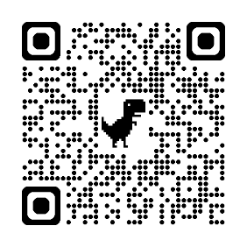
Sample Message to Use: Please protect the Community Services Block Grant (CSBG) and Community Action Agencies across the country. The Community Action Agency in my community is vital to the health & well-being of our community, including those most vulnerable. Community Action employees are a vital part of the local economy. Community Action Agencies are proven to be responsible & efficient stewards of federal grant funds with all programming connected to self-sufficiency, enhancing local economies, and making the American dream possible.
Link to Send Message: OR Snap the QR Code:
https://www.whitehouse.gov/contact/

Sign-on to Letter to Protect Head Start:
No message necessary. Follow the prompts to add your name to the letter to oppose cuts to Head Start & Early Head Start.
Link to Send Message:
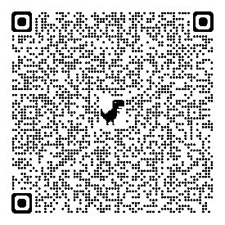
https://nhsa.org/advocacy/act-now-sign-this-letter-to-president-trump-to-save-head-start/?utm_campaign=Insider&utm_medium=email&_hsmi=357862378&utm_content=357862378&utm_source=hs_email
OR Snap the QR Code:

Contacting U.S. Senator Chuck Schumer’s Office:
Send a Message:
Sample Message to Use: Please protect the Community Services Block Grant (CSBG) and Community Action Agencies across the country, including Programs that Community Action Agencies operate, such as Weatherization, Head Start, WIC, SNAP & Medicaid. The Community Action Agency in my community is vital to the health & well-being of our community, including those most vulnerable. Community Action employees are a vital part of the local economy. Community Action Agencies are proven to be responsible & efficient stewards of federal grant funds with all programming connected to self-sufficiency and enhancing local economies and making the American dream possible.
enhancing local economies.
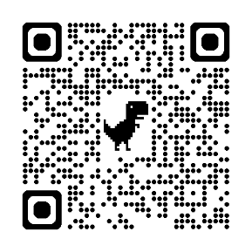
Link to Send Message: OR Snap the QR Code:
https://www.schumer.senate.gov/contact/message-chuck
Call Local Office: (607) 772-6792

Contact U.S. Senator Kirsten Gillibrand’s Office:
Send a Message:
Sample Message to Use: Please protect the Community Services Block Grant (CSBG) and Community Action Agencies across the country, including Programs that Community Action Agencies operate, such as Weatherization, Head Start, WIC, SNAP & Medicaid. The Community Action Agency in my community is vital to the health & well-being of our community, including those most vulnerable. Community Action employees are a vital part of the local economy. Community Action Agencies are proven to be responsible & efficient stewards of federal grant funds with all programming connected to self-sufficiency and enhancing local economies and making the American dream possible.
enhancing local economies.
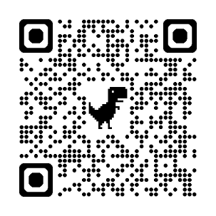
Link to Send Message: OR Snap the QR Code:
https://www.gillibrand.senate.gov/contact/email-me/
Call Local Office: (315) 448-0470

Contact Congresswoman Claudia Tenney:
Send a Message:
Sample Message to Use: Please sign-on to FY2026 CSBG Dear Colleague Letter to protect the Community Services Block Grant (CSBG) and Community Action Agencies across the country, including Programs that Community Action Agencies operate, such as Weatherization, Head Start, WIC, SNAP & Medicaid. The Community Action Agency in my community is vital to the health & well-being of our community, including those most vulnerable. Community Action employees are a vital part of the local economy. Community Action Agencies are proven to be responsible & efficient stewards of federal grant funds with all programming connected to self-sufficiency and enhancing local economies and making the American dream possible.
enhancing local economies.
Link to Send Message:
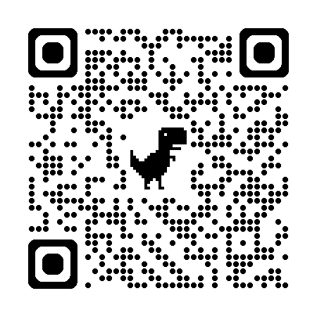
https://tenney.house.gov/contact OR Snap the QR Code:
Call Local Office:

Lockport (716) 514-5130
Canandaigua (585) 869-2060

